Git and Github
Create a directory and entered the directory
Checked the git version and initiated git
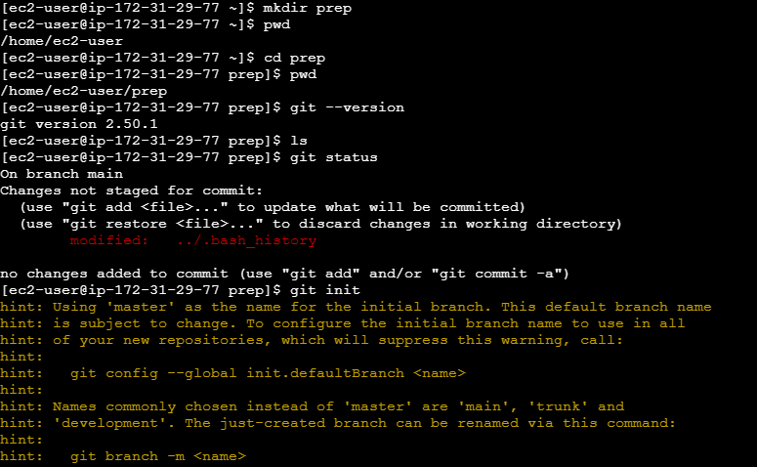
Checked git status and see that no commits yet
Obtained git user name and email using git config –list
Created few files j k l m n o p q
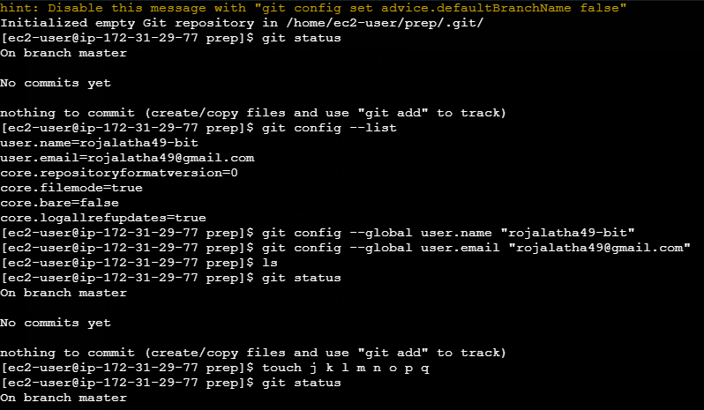
Checked status and see that files are listed in untracked files
Using git add . sent files to tracking area
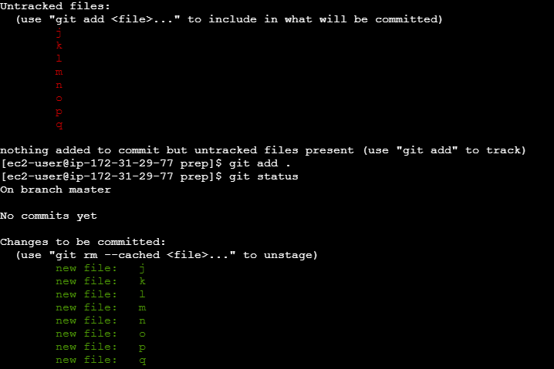
To print all logs for which changes are made used command git log
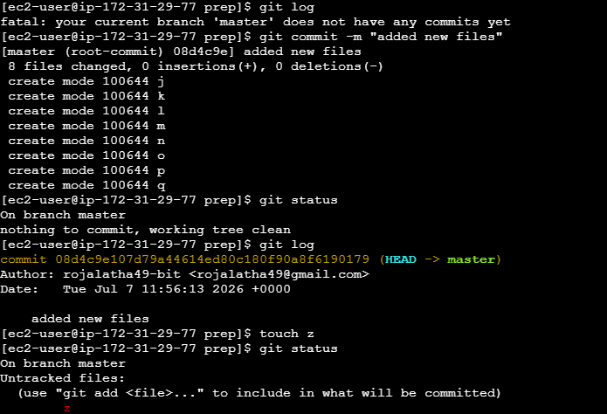
Created keypair using ssh-keygen
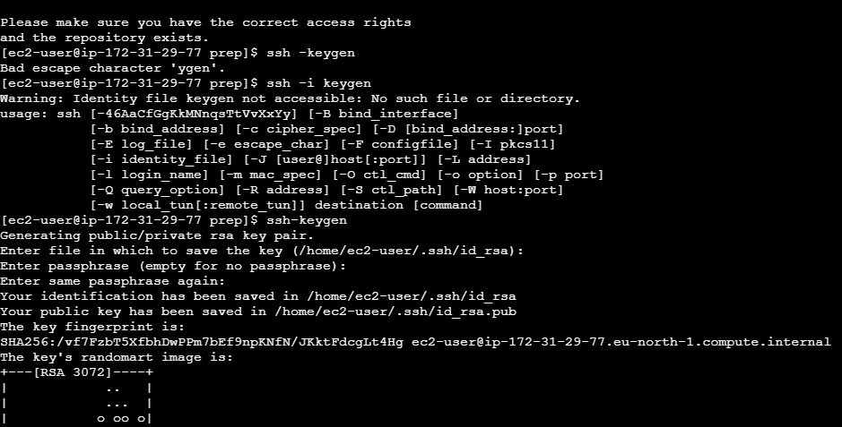

Created a dockerfile and see that it is listed in files
Then deleted dockerfile using rm and when viewed the list, dockerfile is not listed

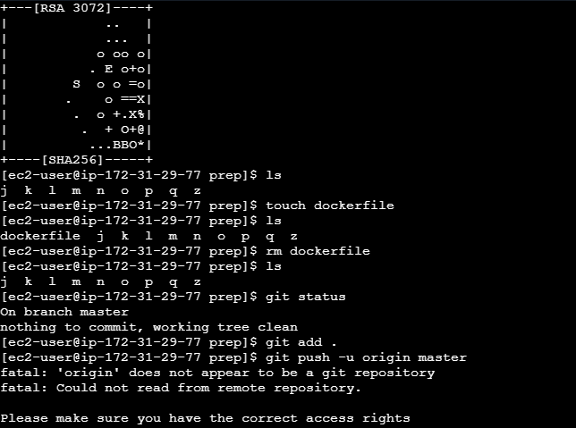
Pushing local master branch to the remote repository using git push –u origin master
Checked remote repositories connected to local Git repository using git remote -v.
Using Git remote add origin https://github.com/rojalatha49-bit/git-commands.git connected local Git repository to a remote GitHub repository.

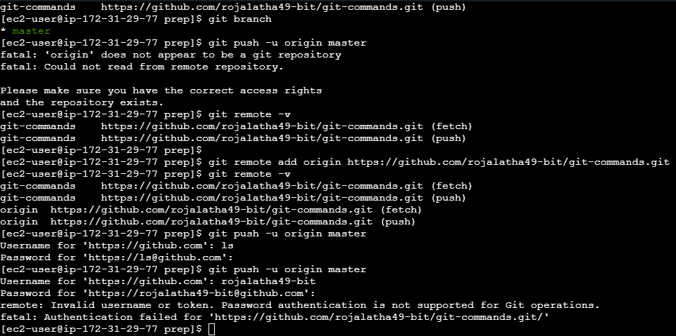

When tried to push the branch to remote repository, it asks for user name and password.
Given user name and password the token created from github and pressed enter and see that files are pushed to remote repository.
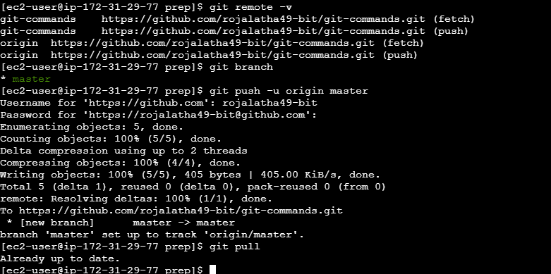
2. Created Git hub account
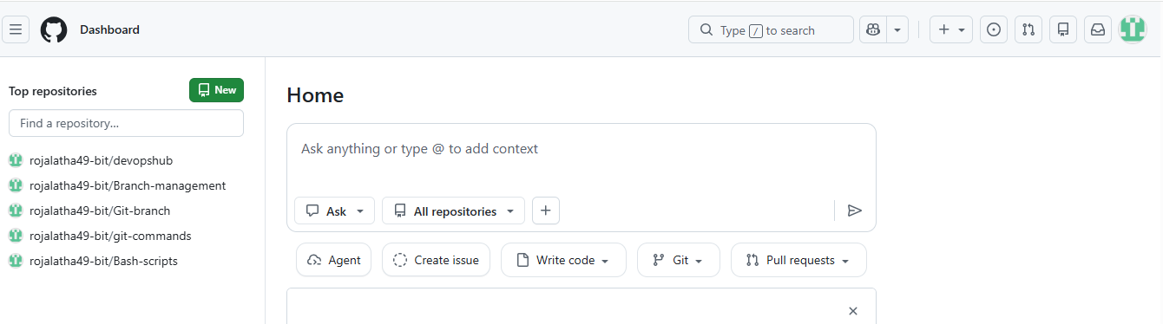

Also checked that files are listed on remote repository:

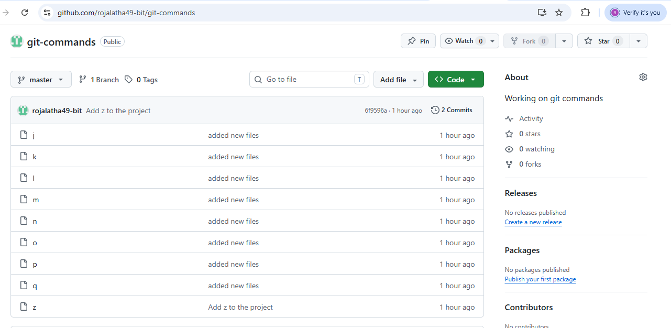

Cloned the git using git repository link
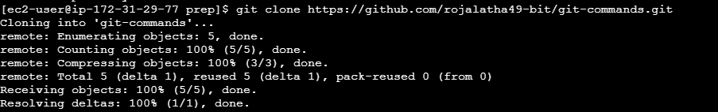
3. MFA (Multi-Factor Authentication) for the GitHub account using a mobile app
